Kafka Integration with C#:

1.Create a Chat Application which uses Kafka as a streaming platform and consume the chat messages in the command prompt.

Starting Kafka Server
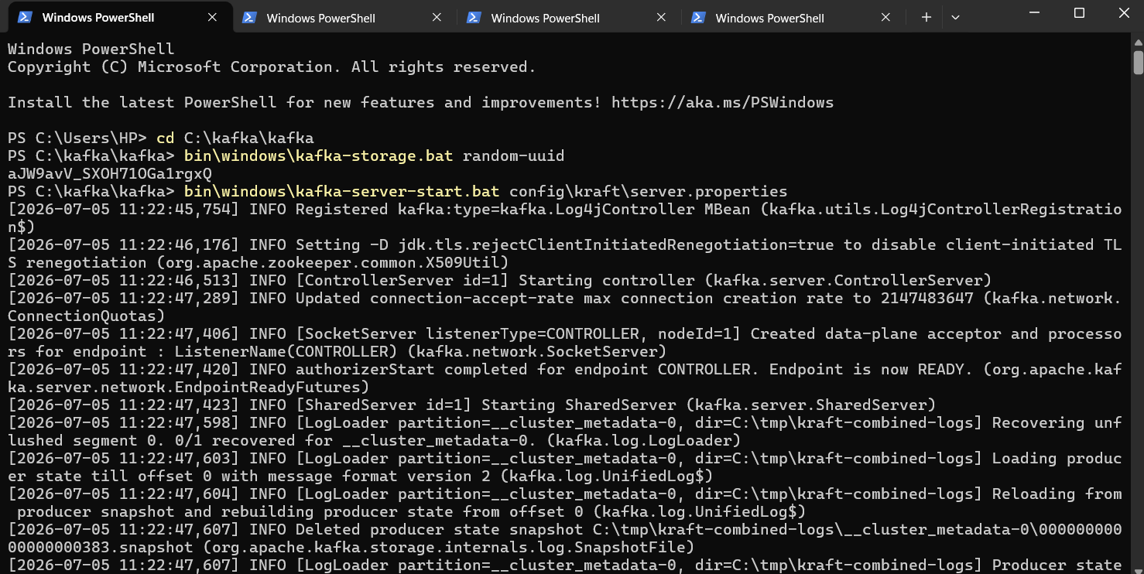

Topic Created
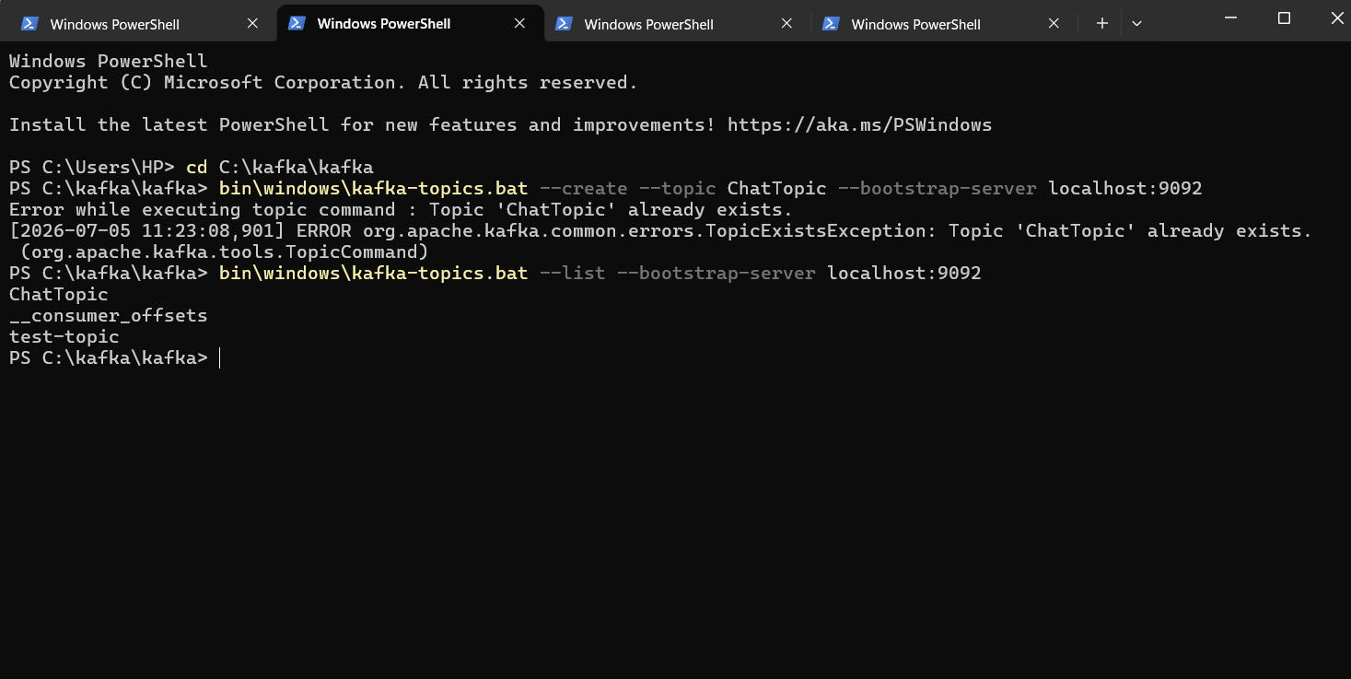

Consumer
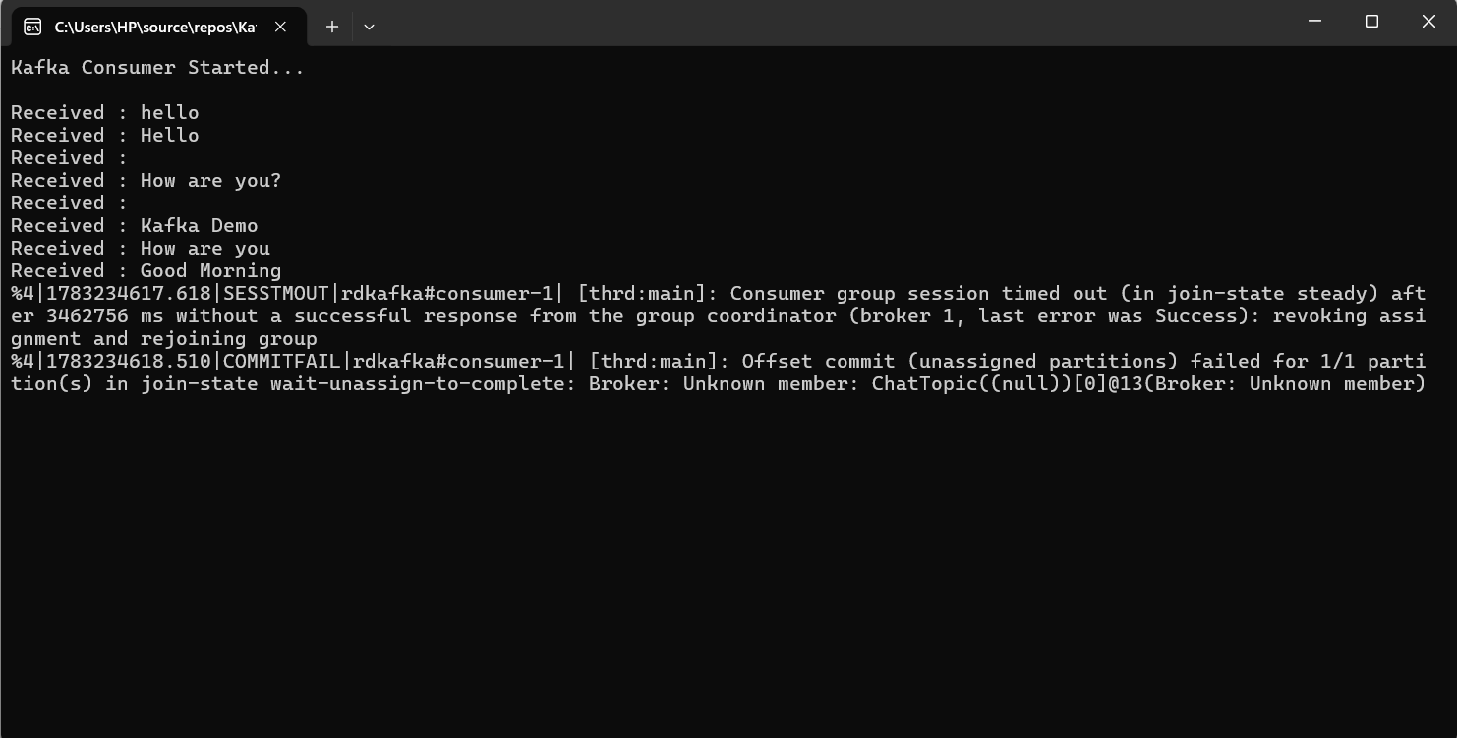

Producer
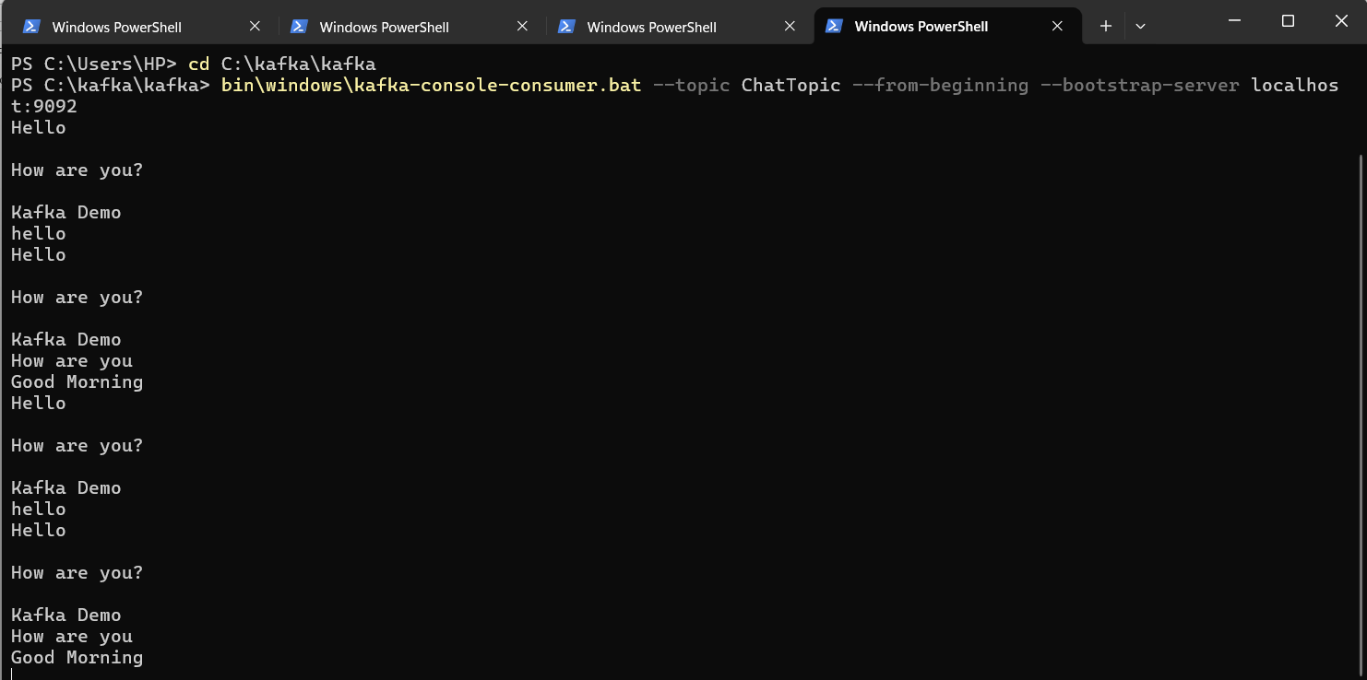

2.Create a Chat Application using C# Windows Application using Kafka and consume the message in different client applications.

Successfully implemented.
Sender(Client 1) sends message to Receiver(Client 2)
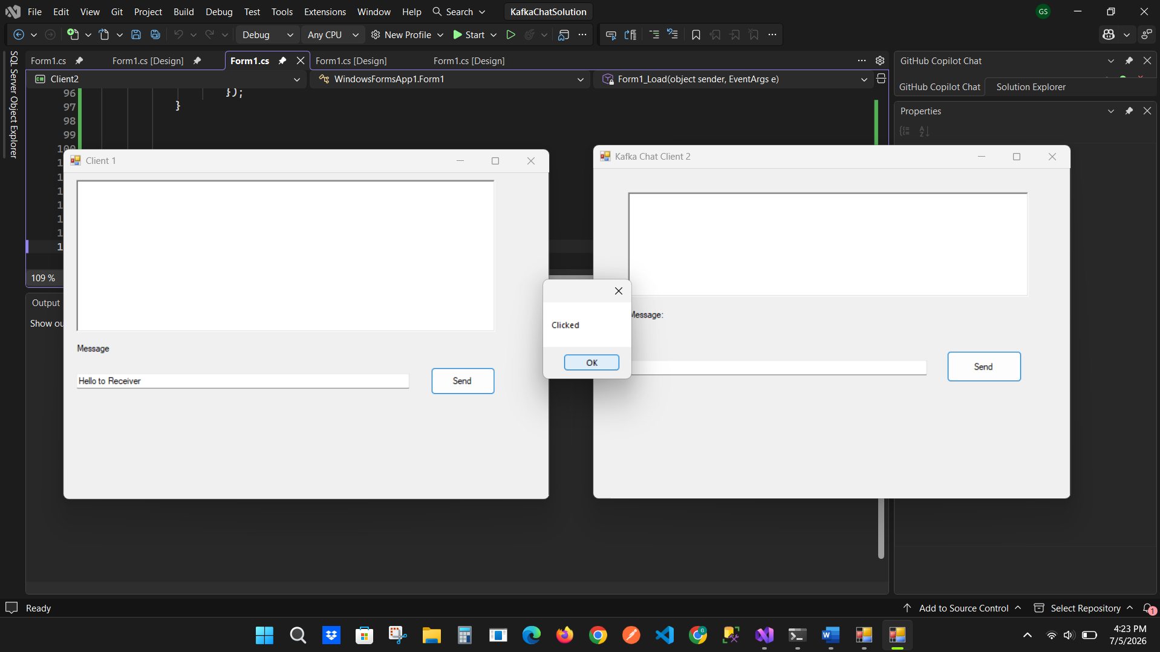

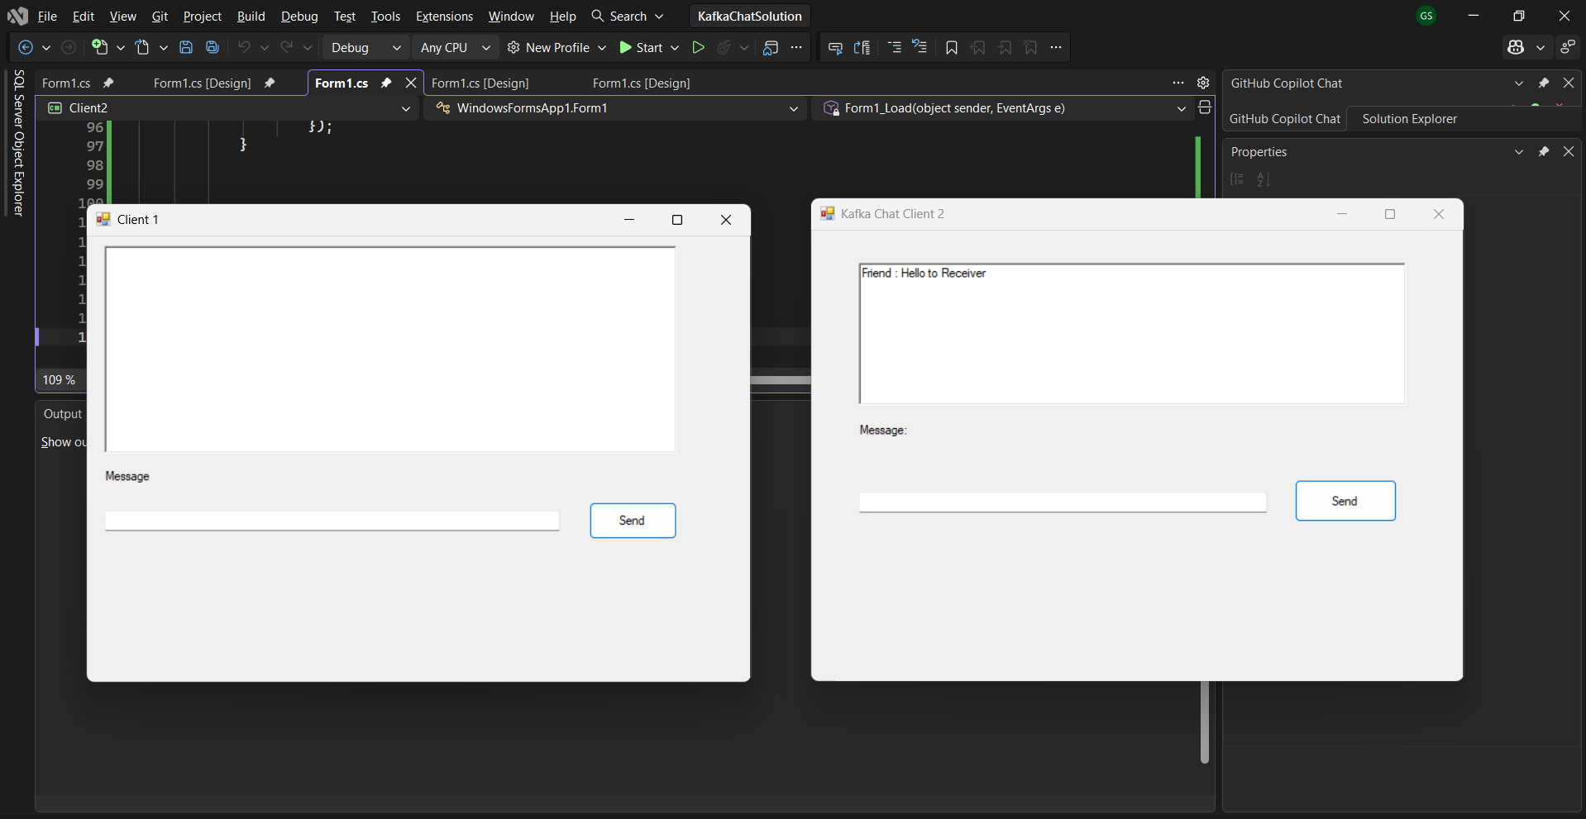

Receiver(Client 2) also sending to Sender(Client 1)
